Hardscrabble Invoice

Hardscrabble Invoice is an invoice management app. Its purpose is to allow the user to upload invoices, OCR them, and give the user a usable edit-and-validation user interface that automatically identifies possible inaccuracies.

Features
Supported Files:
pdf, jpg, png

Limits:
Batch: 100 invoices

Batches:
Invoices are processed in batches. An invoice batch

Upload Process:
After a batch is created and/or selected, clicking the Upload Invoices button will open a dialog box on the user's machine that will allow him to select any number of invoices for upload to that batch.

OCR Process:
HI employs a 3-step OCR process. The main process uses Azure Document Intelligence to OCR the invoice. The secondary process employs a local OCR solution that runs on the invoice.

Invoice Queuing: For later.

Automatic Error Checks:
When both OCR process are done, the results are compared an analyzed for several types of errors:
1. Azure Document Intelligence Field Confidence
2. Secondary OCR Field Confidence
3. Per-field mismatches between the two OCR results
4. Math errors in line items.
5. Math errors in invoice total.

Validation:

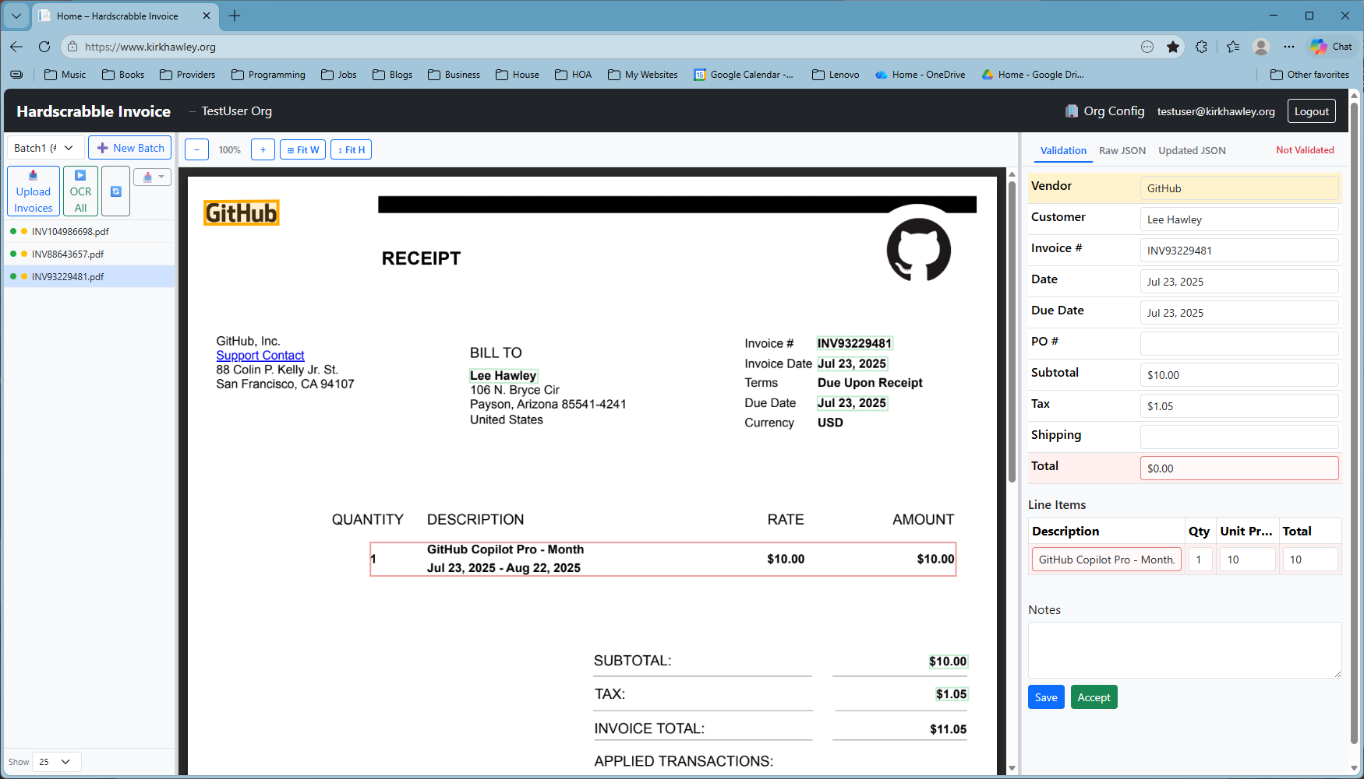
As the user tabs through the fields in the validation panel, the corresponding field is highlighted on the invoice image. If the user clicks on a particular field in either window, the corresponding field is highlighted in the other window.

Possible errors that have been identified by the automatic validation are marked in red. This does not mean that the OCR result is incorrect - just that confidence in that field is low, for one or more of the reasons listed above. When the user verifies that the OCR result doesn't match what he sees on the scanned invoice, he can edit the value.

When the user is done validating the fields, he can save his changes.

He can accept the changes at any time.

Invoice Download:

Organization Deletion
When Organizations are deleted, the data data is retained for 2 weeks. During that period, it is possible to reactivate the Organization by contacting Hardscrabble. When the retention period is over, the Organization and all of its data will be physically and permanently deleted.

Batch Deletion
When batches have been validated and uploaded to the customer, the batch is marked for deletion. The batch will be permanently deleted 14 days after it is marked for deletion.

